EDS Pages and Menus

Table of Contents
1 Introduction 3
2 Pages and Menus for different Role Types 3
2.1 Pages 3
2.2 Menus 4
3 Pages/Forms in employee workflow 5
4 Issues with Menu Activation 5
5 Managing the Save Functionality of Employee Data Screen 6

Introduction
This document describes the activation of menus and pages on saving the Employee Data Screen page. Screen shorts and textual description are used to explain the steps in detail.

Pages and Menus for different Role Types
The WORKTERRA Application has various pages and menus for different role types such as Partner, Broker, Company Admin and Employee.

Pages
Pages/Forms: There are two types of pages in the application:
- System Forms : Following are the system forms available :
- Demographics
- Child
- Spouse
- Employment
- Payroll
- Medicare
- Medicaid
- Education
- Emergency Contact
- Beneficiary
- Confirmation Statement
(There could be more system forms.)
System forms are by default available to Partner, Broker and Company Admin. For employee role type, these systems forms need to be selected and saved in the Employee Data screen as well.
- Additional Forms: These forms are added in the system through Form Builder.

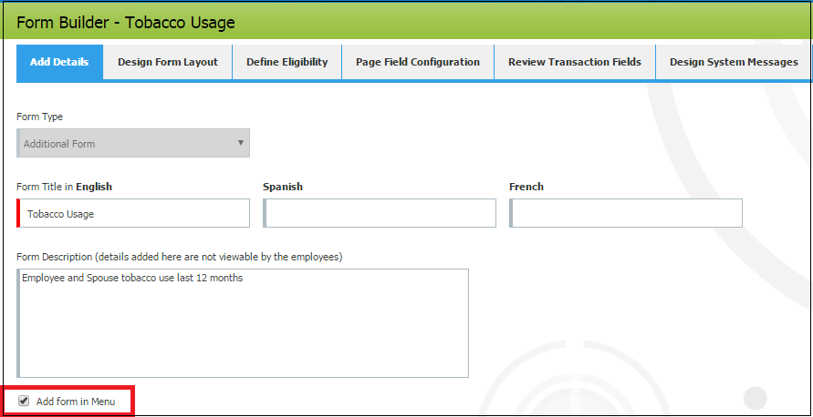
Figure 1: Adding additional form through Form builder

Additional forms are available in employee menu when:
- The flag Add form in Menu is checked for that Additional form (as seen in Figure 1)
- The Additional form is selected and saved in Employee Data Screen.(Figure 3)

Menus
The WORKTERRA Application has a mechanism to allow or disallow menus for Partner, Broker and Company Admin users in the User Access Policy.
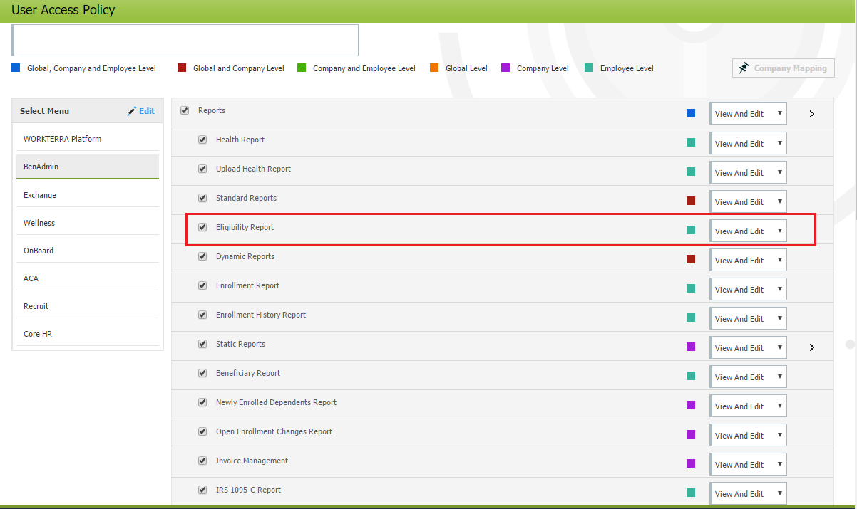
Figure 2: Activating menus using User Access Policy
As highlighted in Figure 2 the Eligibility Report menu will be available to the user who opts for this User Access policy.
The menus for employee are activated/ deactivated through backend database.

Pages/Forms in employee workflow
The WORKTERRA Application has a mechanism to allow selective pages to appear in the employee workflow.

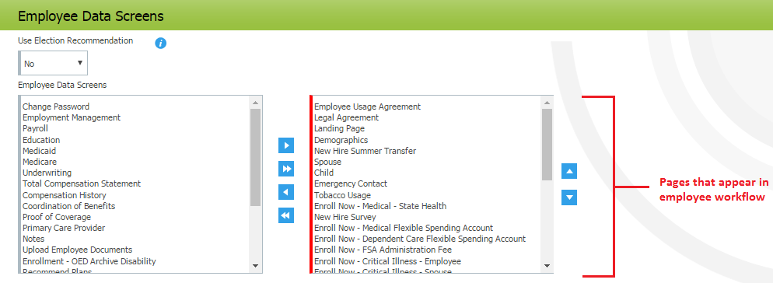
Figure 3: Employee Data Screen
As seen in aboveFigure 3, the Employee Data screen has two list boxes. Both the list boxes contain list of employee pages. These pages are transferred from the left list box to the right list box.
Once the required pages are transferred into the right list box and saved, these pages in the right list box will appear in the employee workflow.

Issues with Menu Activation
Previously when employee data screen was saved it activated the following:
- Pages saved in the employee data screen for the employee workflow ( the right list box as seen in Figure 3)
- The menus in the system such as :
  - Eligibility Report
  - Employee Plan Eligibility Report
  - Employee Timesheet Report
  - Paycheck Management
- (There could be more such menus.)

- These menus are not available in the employee data screen. (Not available in both list boxes Figure 3 )
- Hence saving the Employee Data Screen, activated certain other menus which were not a part of the Employee Data Screen (right list box as Figure 3).
- So upon login Employee could access the menus such as Eligibility report, Employee Timesheet Report etc.
- To hide these menus, they were deactivated from backend, but upon saving Employee Data Screen again, these menus get activated again.
- This also resulted in accessible Parent Menus (such as Employee Screen Configuration), which do not have child menus.(Figure 4)

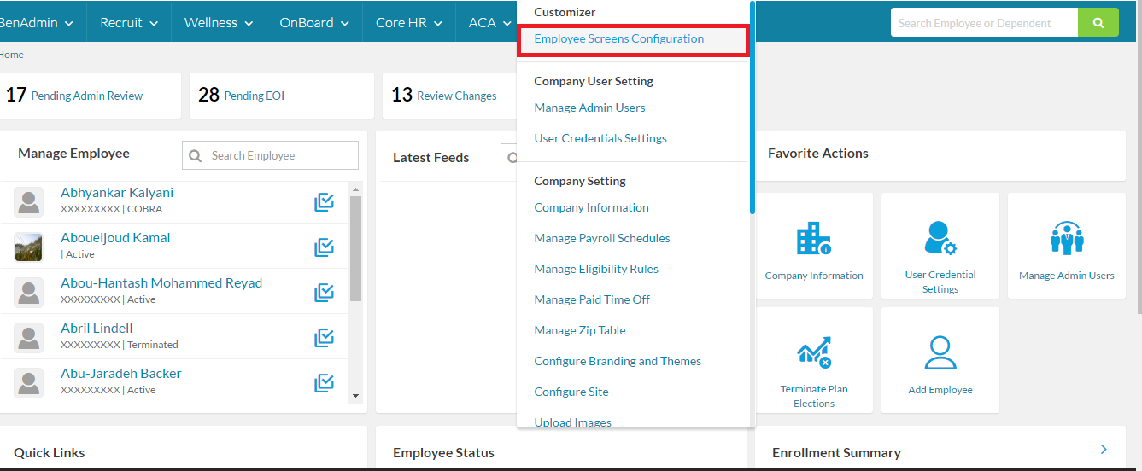
Figure 4 : Employee Screen Configuration

Managing the Save Functionality of Employee Data Screen
To resolve the issues the following approach was implemented
- System forms
Upon saving the system forms in the Employee Data Screen, they will be accessible to the Employee.
NOTE: For System form the Add form in menu flag is checked by default.
- Additional Forms
- Additional form need to have the flag Add form in Menu as checked (as seen in Figure 1)
- Additional Forms need to be saved in Employee Data Screen.

To summarize the above approach we can refer the table below:
Page saved in Employee Data Screen | Add form in Menu | Page accessible in Workflow | Page Accessible in Employee Menu
 | × |  | ×
× | × | × | ×
× |  | × | ×

- Hence saving the employee data screen will activate ONLY the pages present in the employee data screen (right list box as seen in Figure 3).
- It will not activate other menus which are not a part of Employee Data Screen.

